HOW TO WRITE AN ABSTRACT FOR THE XVII CONGRESS OF THE EUROPEAN ASSOCIATION OF THERMOLOGY
E.A.Thermology¹, U.V. Valencia²

1 University of Somewhere
2 University of Somewhere Else
Introduction: The main text of the abstract proposal should be written in Garamond, font size 10. The abstracts should be organized in introduction, methods, results, discussion, acknowledgements and references. The headings of the sections are written in Garamond, bold, font size 10. The text is justified all over the abstract proposal.
Methods: Some of the sections can be omitted by the author or be appropriately renamed according to the context. Some examples for the section names can be background or introduction, materials and methods, results, discussion, conclusion or others.
Images and Tables: Tables, figures and legends for illustrations should appear each on an extra sheet of paper. The text of the abstract submission, excluding the pages of the images and tables should not exceed one page in length.
Instructions for references: References are not compulsory for the abstracts, but recommended for acceptance. References should follow the examples of the next section. If the reference is a book, the last name of the author appears first, followed by the first name initial(s). Then appears the book title, followed by the editor, year and pages.
If the reference is an article, the authors are listed as for a book, followed by the article title. The journal name appears next, as well as the year, volume and pages.
References:

First, A.; Second, A. Title of the first book; 2022. p. 300-4.
First, A.; Second, A. Title of the article 2023; volume; 300-4.

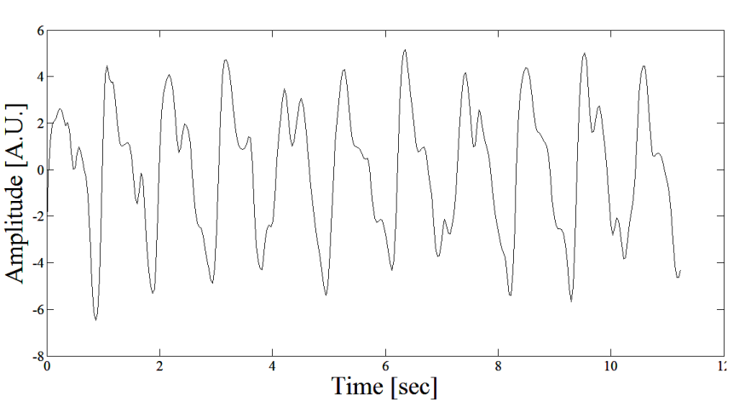
Figure 1 – Title of the first figure.

 | X | Y
X | XX | XY
Y | YX | YY

Table 1 – Description of the first table.

